***GOVERNMENT ARTS COLLEGE (A)***

***SALEM-7***

***DEPARTMENT OF STATISTICS***

***VOYAGE VISTA : ILLUMINATIN***

***INSIGHTS FROM UBER***

***EXPEDITIONARY ANALYSIS***

*V.MANIKANDAN (TEAM LEADER) - 21UST232513*

*NM\_ID:33E6078E84AC27EA4974B363324AEBA3*

*P.DINESH - 21UST232505*

*G.KARTHIKEYAN - 21UST232510*

*P.SURENDRAN - 21UST232518*

***1.INTRODUCTION***

# 1.1 Overview

**Uber is a transportation company with an app that allows passengers to hail a ride and drivers to charge fares and get paid. More specifically, Uber is a ridesharing company that hires independent contractors as drivers.**

**It's one of many services today that contribute to the**[**sharing economy**](https://www.techtarget.com/searchcio/definition/sharing-economy)**, supplying a means of connecting existing resources instead of providing the physical resources themselves.**

**The company was founded by Travis Kalanick and Garrett Camp in 2009, and is headquartered in San Francisco. The company has an estimated 110 million users worldwide.**

**1.2 Purpose**

**The Uber mission statement is “to provide transportation as reliable as running water, everywhere, for everyone.” And the Uber vision statement is “to ignite opportunity by setting the world in motion.”**

**Uber has achieved remarkable success since it was founded in 2009, quickly growing from a local transportation service to an international network firm providing services across 90 countries globally. The company’s goals and methodologies are outlined in its mission and vision statements, which have been highly influential in creating and sustaining Uber’s reputation as a leader in the transportation industry.**

**The vision statement of Uber points to its ongoing effort to provide customers with convenience-based transportation solutions. This is closely related to Uber’s mission statement, which outlines both its strategic aims and the experiences they strive to offer customers through boundless services that meet their needs.**

**In addition, Uber prides itself on its core values, which encompass “being customer-obsessed,” “building globally,” and “celebrating differences” when operating as an organization. All of these elements combined have significantly contributed to making Uber one of the most successful companies in this sector.**

**The Uber mission statement is “to provide transportation as reliable as running water, everywhere, for everyone.” And the Uber vision statement is “to ignite opportunity by setting the world in motion**

***Currently both Uber and Ola cabs are following the strategy of expanding their operations and gaining customer base in various cities in India. The motive is to gain market share and achieve economies of scale all the while providing a delightful customer experience to gain trust***

***Traditional taxis are typically regulated by local governments, have fixed fare rates, and can be hailed on the street or booked in advance. Uber, on the other hand, operates under a different business model. It's a technology platform that connects independent drivers with passengers via a smartphone app.***

***it may take up to 48 hours for your documents to be reviewed and verified.***

***We offer comprehensive healthcare, monthly well-being reimbursements, and assistance programs that connect you to resources. We provide generous paid vacation, sick leave, local holidays, and voting days off.***

***2.PROBLEM THINKING DEFINITION & DESIGN***

**2.1 Empathy Map**

## *C:\Users\VIJI\AppData\Local\Packages\5319275A.WhatsAppDesktop_cv1g1gvanyjgm\TempState\5FD0B37CD7DBBB00F97BA6CE92BF5ADD\WhatsApp Image 2023-10-13 at 13.07.44_9549f147.jpg*

## *2.2 Ideation & Brainstorming Map C:\Users\VIJI\AppData\Local\Packages\5319275A.WhatsAppDesktop_cv1g1gvanyjgm\TempState\2B44928AE11FB9384C4CF38708677C48\WhatsApp Image 2023-10-13 at 13.07.44_426c880c.jpg*

***3.RESULT***

***Income from operations was $326 million, up $1.0 billion YoY and $588 million quarter-over-quarter (“QoQ”). Net income attributable to Uber Technologies, Inc. was $394 million, which includes a $386 million benefit (pre-tax) primarily due to net unrealized gains related to the revaluation of Uber's equity investments***

* ***Gross Bookings of $14.9 billion: Mobility Gross Bookings grew 37% YoY on a constant currency basis. On a sequential basis, Mobility Gross Bookings grew 9% quarter-over-quarter (“QoQ”), with growth in all geographic regions. Revenue of $4.1 billion: Mobility Revenue grew 82% YoY and 8% QoQ Adjusted EBITDA of $916 million, up $552 million YoY. Adjusted EBITDA margin as a percentage of Gross Bookings was 2.7%, up from 1.3% in Q2 2022. Incremental margin as a percentage of Gross Bookings was 12.2% YoY.***
* ***Net cash provided by operating activities was $1.2 billion and free cash flow, defined as net cash flows from operating activities less capital expenditures, was $1.1 billion.***
* ***Unrestricted cash, cash equivalents, and short-term investments were $5.5 billion at the end of the second quarter.***

***DASHBOARD***

***1***

***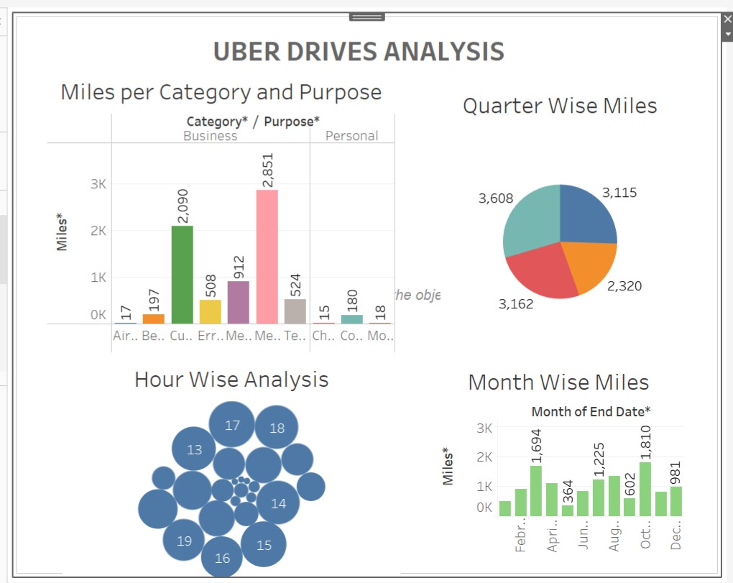2***

***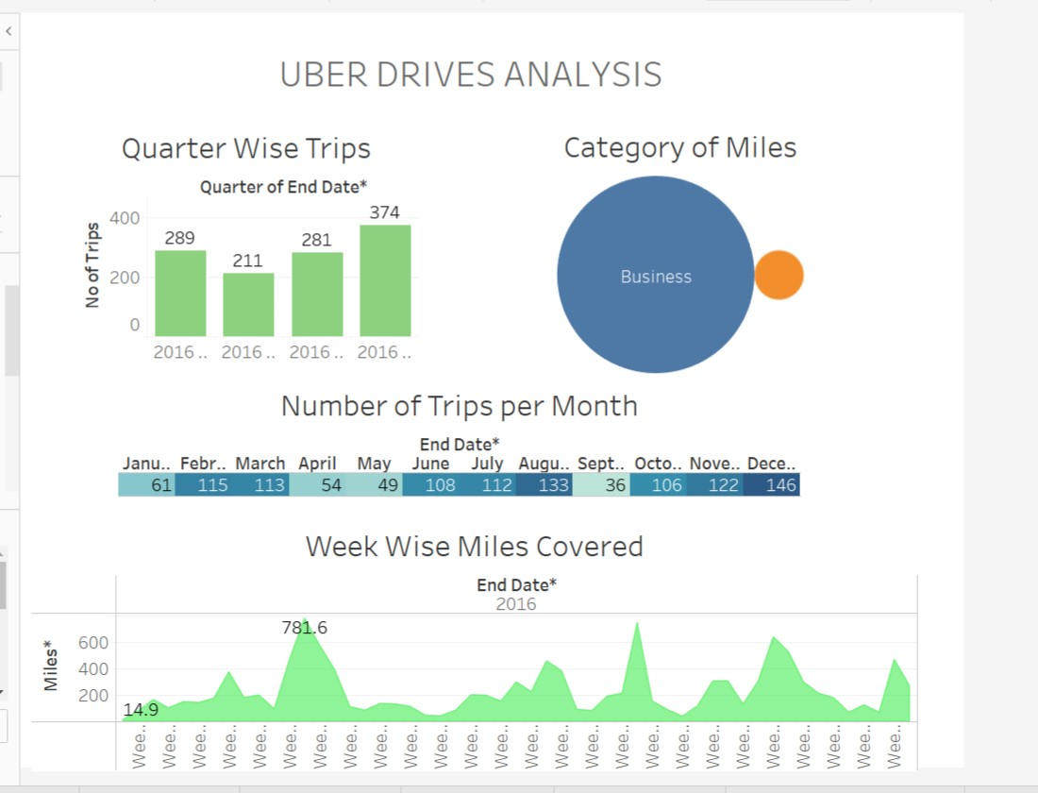***

***STORY***

***1***

***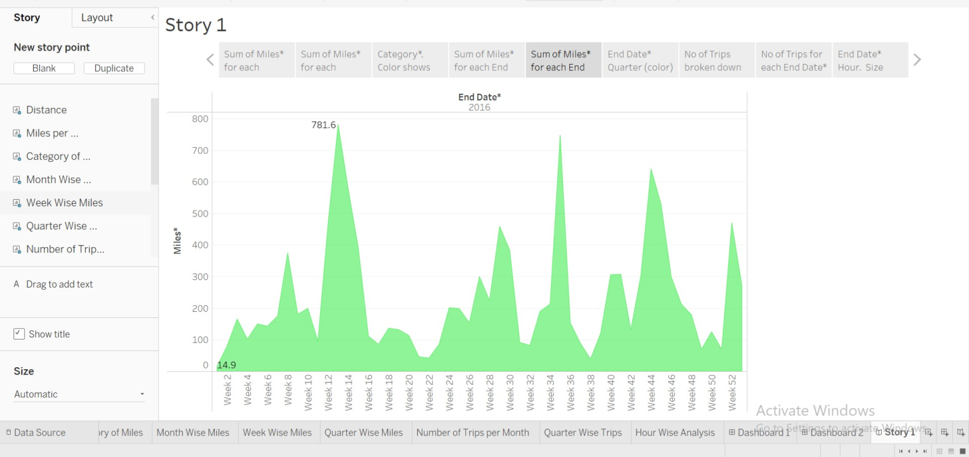***

***2 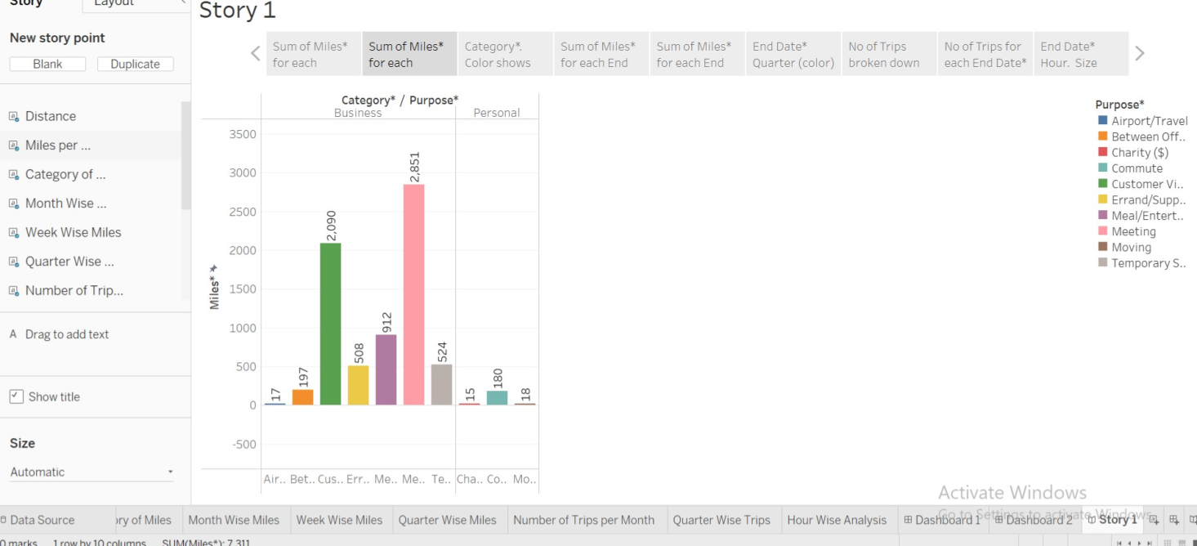***

***3***

***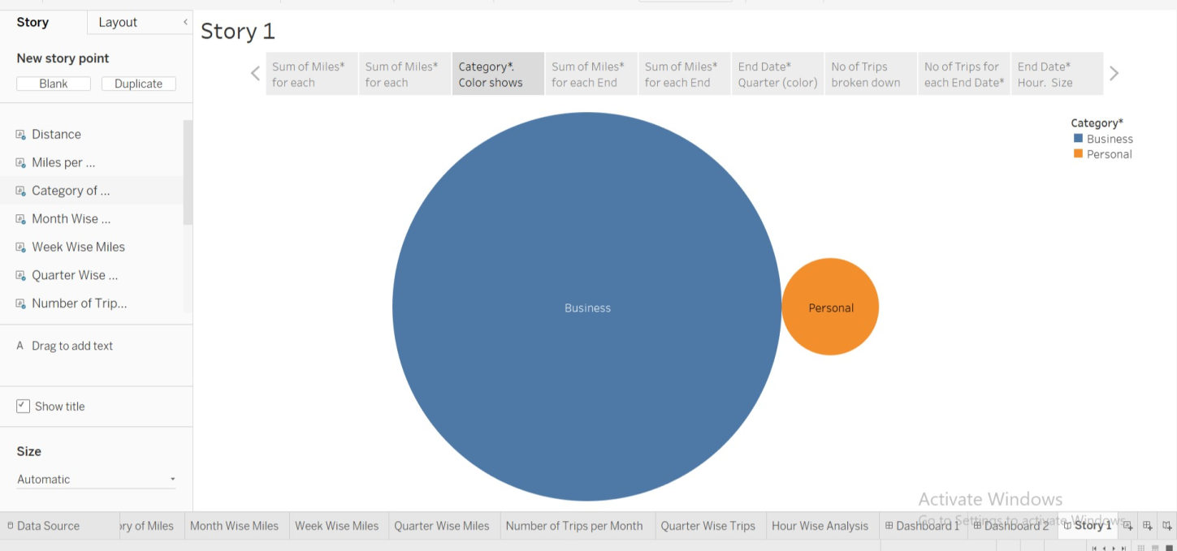***

***4 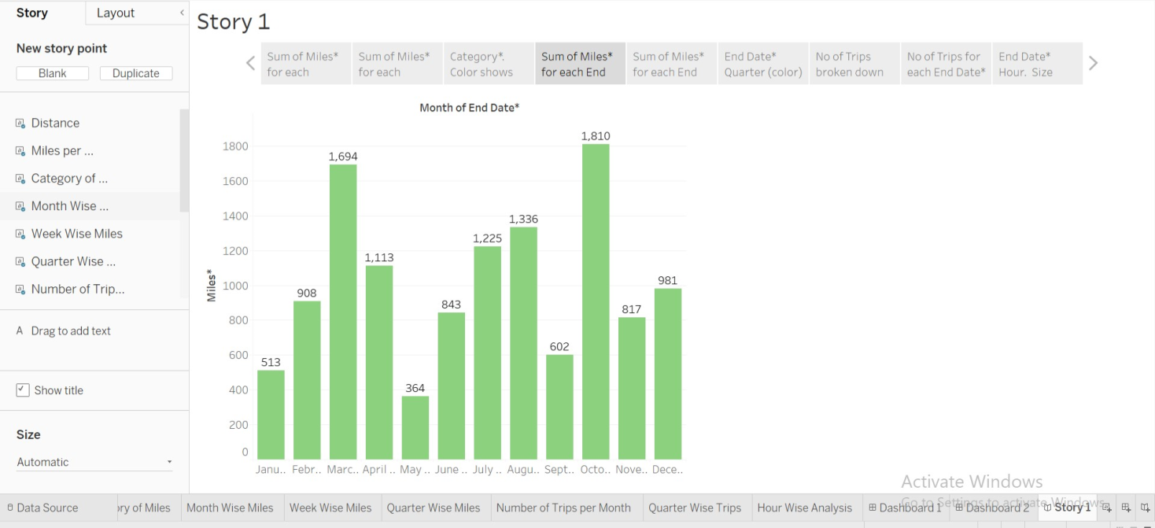***

***5***

***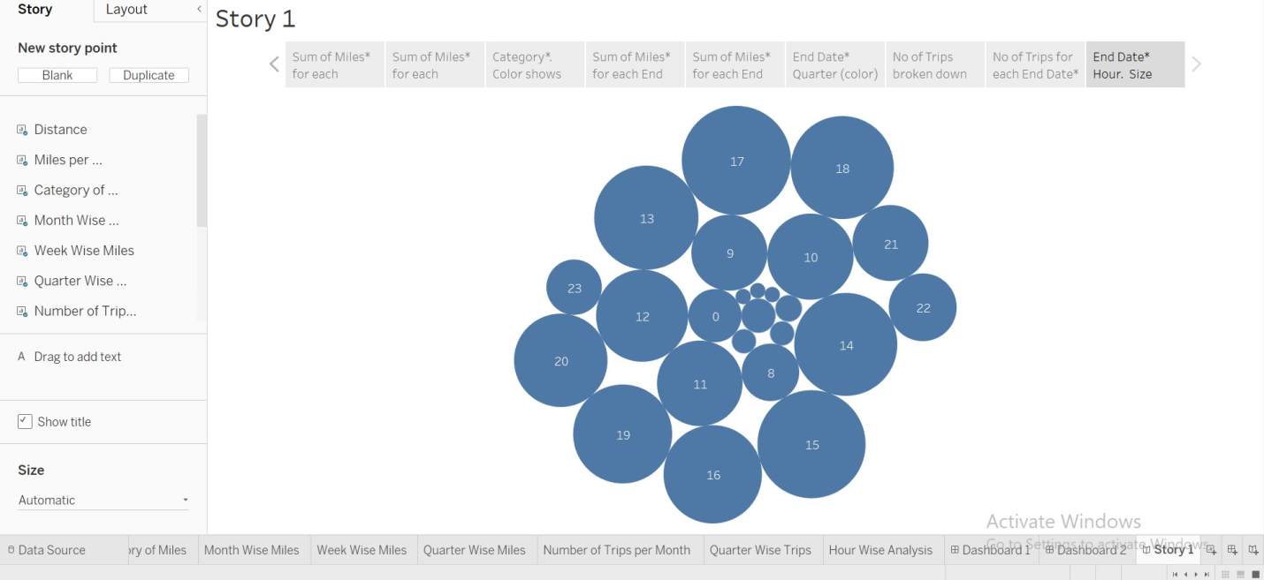***

***6 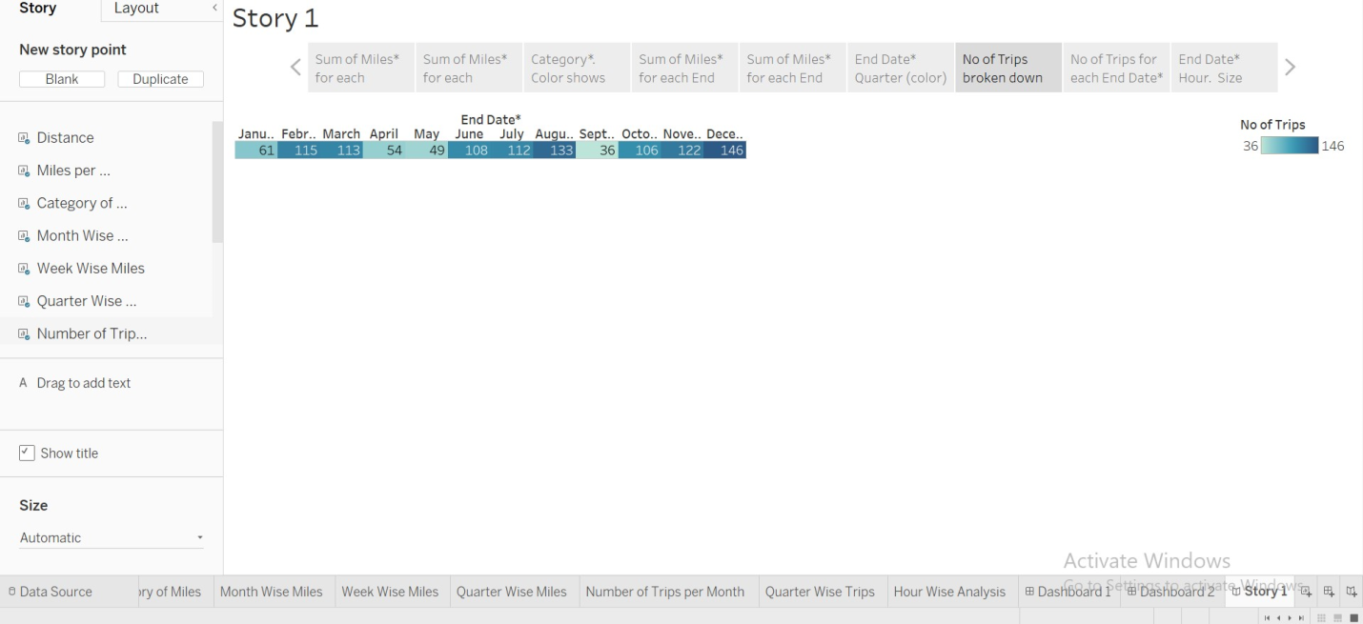***

***7 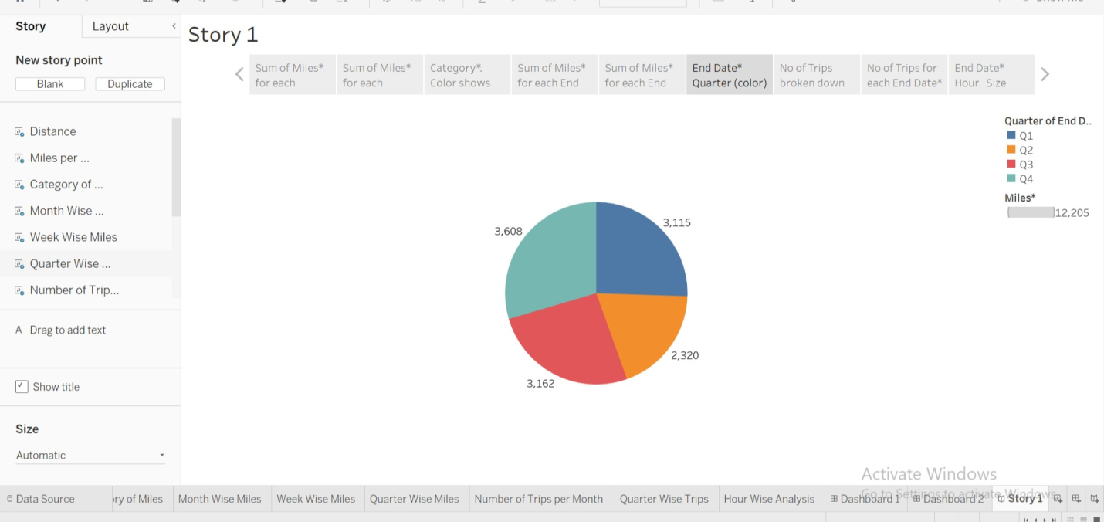***

***8 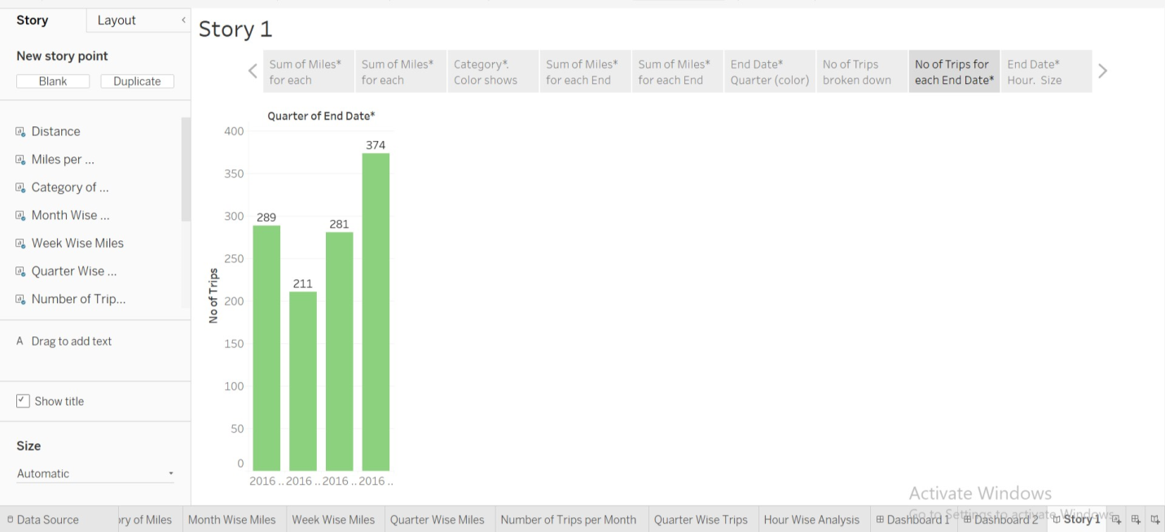***

***4.ADVANTAGES & DISADVANTAGE***

***Advantages***

***Uber's advantages include door-to-door convenience, safety, and reliable quality. Uber's disadvantages include its surge pricing and the negative effects of replacing steady jobs with gig work.***

***The pros of being an Uber driver include having the freedom to pick your hours, meeting new people, and earning some income, while the cons include competing for rides, paying for gas and car maintenance, and possible negative reviews***

***Another source of competitive advantage (as suggested by a recent HBR.org article) could be its avoidance of regulation. Uber uses noncommercial cars, its drivers avoid costly commercial insurance, taxi medallions and other expenses that provide Uber service a cost advantage over traditional taxi services***

***Disadvantages***

***Uber's advantages include door-to-door convenience, safety, and reliable quality. Uber's disadvantages include its surge pricing and the negative effects of replacing steady jobs with gig work.***

1. ***Increased competition among driver.***
2. ***The need to maintain a vehicle that meets Uber's standards.***
3. ***The possibility of receiving negative reviews.***
4. ***Expenses for gas, maintenance, and insurance.***
5. ***Uncertainty about the payment rate for each ride***

***5.APPLICATIONS***

***The Uber app gives you the power to get where you want to go with access to different types of rides across more than 10,000 cities. View ride options***

***Let's begin.***

***Step 1: Define target markets for your Uber app alternative.***

***Step 2: Research and pick your ride-sharing app business model.***

***Step 3: Ride-sharing app MVP development.***

***Step 4: Marketing and user acquisition.***

***Step 5: Further development and growth.***

***Step 6: Fraud preventi***

***6 CONCLUSION***

***Uber Technologies, Inc. (commonly referred to as Uber) provides ride-hailing services, food delivery, and freight transport. It is headquartered in San Francisco and operates in approximately 70 countries and 10,500 cities worldwide.***

***The Uber mission statement is “to provide transportation as reliable as running water, everywhere, for everyone.” And the Uber vision statement is “to ignite opportunity by setting the world in motion.”***

***Visit the Activity section of your Uber app to view your complete Uber history (including Uber Eats orders) and save receipts for each trip. Select a trip to view additional details and submit a report as needed***

***7 FUTURE SCOPE***

***The current world is witnessing many advancements and a lot of startups are evolving rigorously in the world for the past few years. All because of the emergence of on-demand ideas in the current business world with a lot of opportunities. The on-demand apps assist you to order or book anything from anywhere.***

***The on-demand business also aids many***[***startups to earn more profits***](https://www.mindxmaster.com/top-5-ways-to-start-the-engineering-startup-and-get-good-profit-quickly/)***. Even more traditional businesses have adopted on-demand business to increase their profits tremendously.***

***With this spark, some of the creative-minded startups have focused their vision on the on-demand business. If you are the one having any on-demand business idea on your mind and want to reach your target audience like Uber,  then this might be the perfect blog to understand the future scope and demands of the***[***on-demand business***](https://www.mindxmaster.com/why-business-owners-invest-in-on-demand-mobile-apps/)***,***

***Let us get into the post to know more about the Uber-like on-demand business,***

## *****Trending ideas and demands for the on-demand industry*****

***Through the digital medium, it is much better and becomes easy to connect with the people in all the aspects. In the on-demand industry, there are abundant choices to choose from.***

***It plays a***[***major role in our day to day life***](https://www.mindxmaster.com/how-to-handle-major-life-changes/)***. Business on such demand will help you to reach greater heights and also fulfill the customer needs.***

## *****Scope of Uber-like on-demand startups*****

***As we all know, the on-demand business has been well developed and it is brimming very well. Within a few years, the on-demand industry is getting more attention due to its quickest growth rate. and the growth of the on-demand industry reaches tremendous speed in this trending world.***

***The on-demand industry has revolutionized the current business models according to the latest trends and ideas with the specialized set of features, functionalities, technologies that satisfy the***[***customer’s expectations***](https://www.mindxmaster.com/why-mobile-app-is-the-best-solution-to-boost-sales-in-the-holiday-season/)***.  It also provides efficiency, flexibility, and building strong relationships of a business.***

***Meanwhile, it has been observed that the majority of the leading entrepreneurs and***[***startups are ready to start their on-demand business***](https://www.mindxmaster.com/why-business-trips-are-vital-for-new-startups/)***with the current trends.***

## *****Future possibilities*****

***The on-demand industry is expected to grow with the four following prior values, including speed, comfort, perfection, and quality in what they deliver. As well as, the growth of the on-demand industry provides numerous benefits for startups.***

***The benefits of the on-demand industry are highly efficient and also helps in scaling the business to greater heights. It has come up with many awesome features that will help you to attain your***[***on-demand goal***](https://www.mindxmaster.com/5-important-things-to-consider-while-developing-a-last-mile-delivery-app/)***and also provide you some unique experience that meets all your requirements.***

***Hence, many startups are interested in expanding their business using on-demand ideas. So, we can expect a bright future for the on-demand industry.***

## *****Reason for the success*****

***With no time to wait, the on-demand services serve as the best choice and have become the perfect solution in this modern world to get exactly what they want.  Hence, there are many other several factors that are responsible for the growth and development of the on-demand industry.***

***Here are some of the prominent reasons for the success and growth of the on-demand industry,***

* ***Advancements in technologies***
* ***Gaining competitive advantage***
* ***Providing a unique experience***
* ***Easy availability and use***
* ***More choices for business space***
* ***Flexibility and affordability***

## *****Find your unique space in the on-demand industry*****

***For any startups who want to start their***[***business journey, the on-demand business has become one of the favorite choices for all the startups***](https://www.mindxmaster.com/tech-tips-to-know-for-your-startup-business-this-year/)***. As well, the on-demand business has a bright scope in the future. Hence, every***[***startup is ready to start their own business***](https://www.mindxmaster.com/free-tools-you-can-use-for-your-new-startup-business/)***and invest their money in an on-demand industry.***

***Moreover, most of the businesses are taking advantage of the possibilities and benefits offered by the on-demand industry to thrive in today’s competitive world.***

***So, it’s your time to find the space in the fast-evolving on-demand industry with the following process***